This is a simple tutorial that will tell you on how to make an object in Unity spin as if it was a collectable item.

**Step by Steps:**

1. E:\UnityTutorials\Rotation\PrintScreens\PS1.PNGSo we are now on a blank scene called the sample screen, now the first thing I am going to do is create a new scene as previously mentioned in the last tutorial of **Colour-Change** I prefer to make the sample scene empty as it lets me load the scenes I want to when everything is loaded rather than a scene I won’t be editing on that day. (I will be acting as if you have read my previous tutorial on **Colour-Change**, so I will assume you know some of the basics of Unity’s interface) I am going to call this scene **Rotation.**
2. E:\UnityTutorials\Movement\PrintScreens\PS2.PNGSo after that lets go into how new scene, then I am going to create a new folder called **Scripts**, so I have somewhere to store scripts
3. Then let’s create a new C# Script and call it something like **Rotation** and as usual double click it to open the script itself
4. 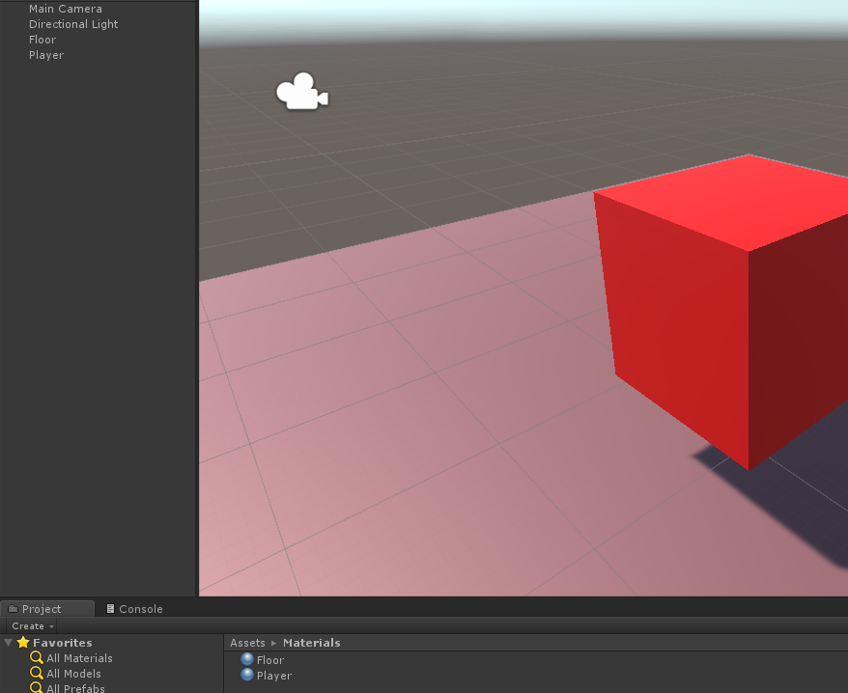Now let’s create a scene that lets us test our script. I usually use a 3d Plane followed by a 3D Cube. I then make them two different materials so I can easily tell them apart.
5. Now let’s go to the script (also do add the script to the object that you want to rotate by either adding it through using add component or just dragging it to the object). I will be using PowerPoint to explain the script as the image quality is better.